In 2010 the Utah Division of Water Quality conducted a nutrient limitation study using nutrient diffusing substrates. The goals of this project were three fold,

- Determine nutrient limitation at low level, reference condition, nutrient concentrations and how this changes with nutrient enrichment
- Determine the impact of point sources on nutrient limitation and algal growth.
- Evaluate the effectiveness of using nutrient diffusing substrates as a means of determining site specific nutrient limitation.

Nutrient diffusing substrates (NDS) are a commonly used method for determining nutrient limitation in stream ecosystems. We used NDS that release nutrients from an infused agar through a solid porous substrate into the water column. The solid porous substrate can be removed and analyzed for algal growth under differing nutrient additions. NDS provide a cost effective method to determine nutrient limitation in stream ecosystems.

We conducted NDS experiments above and below seven waste water treatment plant discharges and at 15 reference sites from July to August. At each site we deployed NDS with four nutrient treatments, control, nitrogen, phosphorus and nitrogen + phosphorus, with three replicates each. NDS were placed in the streambed for an average of 21 days, collected, preserved and delivered to the State Water Lab for chlorophyll a analysis. Surface water nutrients were also collected a minimum of three times during NDS deployment and were analyzed at the Aquatic Biogeochemistry Laboratory at Utah State University.

We studied nutrient limitation at streams with three levels of surface water nutrient concentrations, Low (reference sites, TN 0.24 & TP 0.025 mg/L), Medium (above WWTP discharges, TN 1.32 & TP 0.084 mg/L) and High (below WWTP discharges, TN 6.17 & TP 1.8 mg/L). We found that at Low levels of nutrients sites were likely to be N limited or N + P colimited. At Medium levels of nutrient enrichment limitation was more variable and at High levels of nutrient enrichment algal growth was most likely not to be nutrient limited (Table 1).
Table 1. Limitation of algal growth for each treatment (low, medium & high). Each count represents one stream site. Limitation was determined using a 2 way ANOVA with replication. N1 P2 indicates primary N limitation with secondary P limitation.

P1 N2
N1 P2 P2
N+P
P
N
None
0
1
0
0
0
6
0
1
1
2
1
2
0
2
5
0
5
3
Low
Medium
High

A breakdown of the sites based on limitation revealed an interesting trend. Sites that were not limited by nutrients (“None” in Table 1) had much higher mean surface water nutrient concentrations (TN 4.3 & TP 1.17 mg/L) than sites that were limited by any combination of nutrients (TN 0.72 & TP 0.06 mg/L). Although the mean nutrient concentrations in not limited sites were much higher than limited sites there was also a much higher variation in nutrient concentrations at the not limited sites. We suggest that there are two main reasons why algal growth would not be limited by nutrients. Sites with low surface water nutrients could also be limited by some other site specific factor, likely light limitation from heavy canopy cover. Secondly, at sites with high surface water nutrients algae have all the available nutrients they need for unlimited growth and added nutrients through NDS has no affe0ct on growth.

To evaluate the effects of point sources on nutrient limitation and algal growth we deployed NDS in receiving waters directly upstream and downstream of WWTP plant discharges. We found that the most common point source effect was that a site went from some form of nutrient limitation to becoming not nutrient limited below the discharge (Table 2). Although sites below WWTP discharges were most likely not to be nutrient limited there were a number a possible nutrient limitation combinations possible on the same waterbody above the discharge. This suggests that although nutrients are likely increase algal growth the specific nutrient and the concentration at which the nutrients will alter nutrient limitation from a point source will be specific to the receiving water.
Table 2. Limiting nutrient and water column nutrient concentrations above and below each of the seven WWTP test sites.

Water Column Nutrients

TN mg/L
TP mg/L
Limiting Nutrient
Above Below
Above Below
Above Below
None | None | 2.22 | 11.29 | 0.135 | 1.894
N | None* | 1.20 | 1.08 | 0.076 | 0.084
P | None | 2.83 | 3.45 | 0.218 | 0.266
N+P | None | 0.32 | 14.72 | 0.015 | 2.21
None | None | 1.29 | 1.55 | 0.025 | 0.099
P | None | 1.23 | 10.42 | 0.033 | 7.89
N1 P2  * Likely light limited. Site has a 94% canopy cover. | N1 P2 | 0.11 | 0.125 | 0.009 | 0.020
Dry Ck @ Spanish Fork
Little Bear River @ Wellsville Lagoons
Malad River @ Tremonton
Silver Creek @ Snyderville Basin
San Pitch River @ Fairview
San Pitch River @ Moroni Feed
Weber River @ Oakley City

The second test to evaluate the impacts of WWTP discharges on algal growth was to compare total algal growth between the two locations, above and below WWTP discharges. We found that there was a significant increase between all NDS treatments from the above and below sites. Further analysis revealed that at five of the seven individual waterbodies algal growth was significantly higher below the WWTP discharges. Only Dry Creek @ Spanish Fork and the Malad River @ Tremonton showed no differences between algal growth at the above and below sites. Comparing the mean values for chlorophyll a we can see that algal growth rates were highest at the below WWTP sites (Figure 1 A). If we compare algal growth relative to the control among the three treatment locations we can see that, not surprisingly, adding nutrients had the greatest effect on reference sites (Figure 1 B). These results also indicate that nitrogen and especially nitrogen and phosphorus added together have the greatest impact on algal growth.

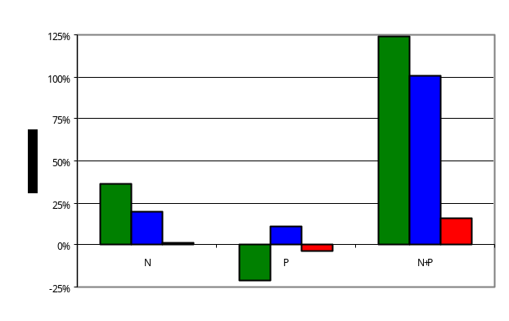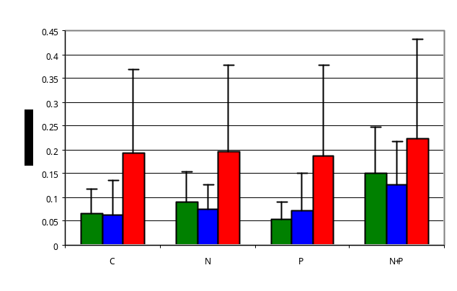
A
B
Reference Sites
Above WWTP Discharge
Below WWTP Discharge
A
B
Figure 1. A) Mean algal growth rate (mg chl a/m2/day) between the three locations (reference, above & below WWTP discharges) and among the four nutrient treatments (control, nitrogen, phosphorus & nitrogen + phosphorus). B) Comparison of algal growth among locations and treatments relative to the control values shown as percent change from control.

Deploying NDS was part of a larger project to develop scientifically defensible numeric nutrient criteria in Utah. We categorized all sites into two groups based on their limitation (any form of limitation sites and no limitation sites). We then used Classification And Regression Trees (CART) to determine significant breakpoints in surface water nutrients where limitation was likely to change from any limitation to the no limitation condition. We found that at any surface water concentrations above 0.42 mg/l TN and 0.078 mg/l TP sites were more likely not to be nutrient limited. This suggests, on average, sites above these values are saturated with nutrients and algal growth is only limited by physical factors (substrate, temperature, light, etc.). Overall TN had a stronger influence on sites becoming not limited than TP (PRE 0. 0.412 & 0.303, respectively).

The final goal of this project was to determine if NDS were a cost effective method of determining nutrient limitation at a site specific basis. We were able to discern clear results at 30 of our 35 deployments. Two of the five sites were dropped because the NDS housing was damaged or lost, likely due to high stream flows. This problem can usually be fixed by finding better deployment locations within a stream. Unfortunately this problem cannot be totally avoided as NDS need to be in stream for approximately 21 days for algal colonization. There is always a chance with deployments that stream conditions can change and the NDS house can be damaged. At three of the sites the NDS housing suffered issues with sedimentation that prohibited algal growth. This is a more difficult problem to address as streams with soft, shifting bottom substrates or high sedimentation rates are difficult to assess nutrient limitation with NDS deployments.

Overall a successful deployment 30 out of 35 times is a good rate but we need to develop a method for assessing nutrient limitation at sites where NDS deployments are not a practical method. For the 2011 field season the DWQ will be assessing the ability to sample algal cells for carbon to nitrogen to phosphorus (CNP) ratios. This method has been used in academic studies to assess nutrient limitation and we will select a small number of sites to evaluate its effectiveness. Although on a large scale CNP ratios can be more expensive than NDS deployments they have the advantage of sampling naturally occurring stream algae and require no long term equipment deployments. We will have a report comparing nutrient limitation results from NDS and CNP ratio studies from the same stream site in early 2012. A second suggestion from this study is to increase the number of replicates for each NDS treatment from three to five. NDS are relatively cheap to produce in mass and the increased replicates will help with statistical analysis and help offset issues with lost or damaged replicates during deployment.

Mike Shupryt
Environmental Scientist III
Utah Division of Water Quality

